CODE:

#include <stdio.h>

#include <stdlib.h>

#include <ctype.h>

enum token {NUMBER, PLUS, MINUS, MULT, DIV, END, INVALID};

enum token current_token;

int current_value;

int error_flag = 0; // Global flag to track errors

void print_token(enum token t) {

switch (t) {

case NUMBER: printf("\nPARSER_INTEGER---------(%d) ", current_value); break;

case PLUS: printf("\nPARSER_SYMBOL_PLUS-----(+) "); break;

case MINUS: printf("\nPARSER_SYMBOL_MINUS-----(-) "); break;

case MULT: printf("\nPARSER_SYMBOL_MULT-----(*) "); break;

case DIV: printf("\nPARSER_SYMBOL_DIV------(/) "); break;

case END: printf("\nEND\n"); break;

case INVALID: printf("\nINVALID_TOKEN "); break;

}

}

void get_token(char *expr, int *index) {

while (isspace(expr[*index])) (*index)++; // Skip whitespace

if (isdigit(expr[*index])) {

current_token = NUMBER;

current_value = 0;

while (isdigit(expr[*index])) {

current_value = current_value * 10 + (expr[*index] - '0');

(*index)++;

}

} else {

switch (expr[*index]) {

case '+': current_token = PLUS; (*index)++; break;

case '-': current_token = MINUS; (*index)++; break;

case '*': current_token = MULT; (*index)++; break;

case '/': current_token = DIV; (*index)++; break;

case '\0': current_token = END; break;

default: current_token = INVALID; (*index)++; error_flag = 1; break;

}

}

if (current_token != INVALID) {

print_token(current_token); // Print the token only if it's valid

}

}

void error_recovery(char *expr, int *index) {

printf("\nError detected, skipping to next valid token...\n");

while (current_token == INVALID) {

get_token(expr, index); // Skip erroneous tokens

}

}

int term(char *expr, int *index);

int factor(char *expr, int *index);

int term(char *expr, int *index) {

int result = 0;

if (current_token == NUMBER) {

result = current_value;

get_token(expr, index);

} else {

printf("\nSyntax error: Expected number, found ");

print_token(current_token); // Print invalid token

error_flag = 1;

error_recovery(expr, index);

result = 0; // Assign default value so calculation continues

}

return result;

}

int factor(char *expr, int *index) {

int result = term(expr, index);

while (current_token == MULT || current_token == DIV) {

if (current_token == MULT) {

get_token(expr, index);

result *= term(expr, index);

} else if (current_token == DIV) {

get_token(expr, index);

int divisor = term(expr, index);

if (divisor == 0) {

printf("\nError: Division by zero! Assuming result as 1.\n");

error_flag = 1;

result = 1; // Default value to prevent crashing

} else {

result /= divisor;

}

}

}

return result;

}

int expr(char *expr, int *index) {

int result = factor(expr, index);

while (current_token == PLUS || current_token == MINUS) {

if (current_token == PLUS) {

get_token(expr, index);

result += factor(expr, index);

} else if (current_token == MINUS) {

get_token(expr, index);

result -= factor(expr, index);

}

}

return result;

}

int main() {

char expr_input[100];

printf("Enter an arithmetic expression using(\"+-*/\"): ");

fgets(expr_input, sizeof(expr_input), stdin);

int index = 0;

get_token(expr_input, &index);

int result = expr(expr_input, &index);

if (current_token == END) {

if (error_flag) {

printf("\nFinal_result of the operation (with errors corrected): %d\n", result);

} else {

printf("\nFinal_result of the operation: %d\n", result);

}

} else {

printf("\nError: Unexpected token at end of expression. Partial result: %d\n", result);

}

return 0;

}

**Output:**

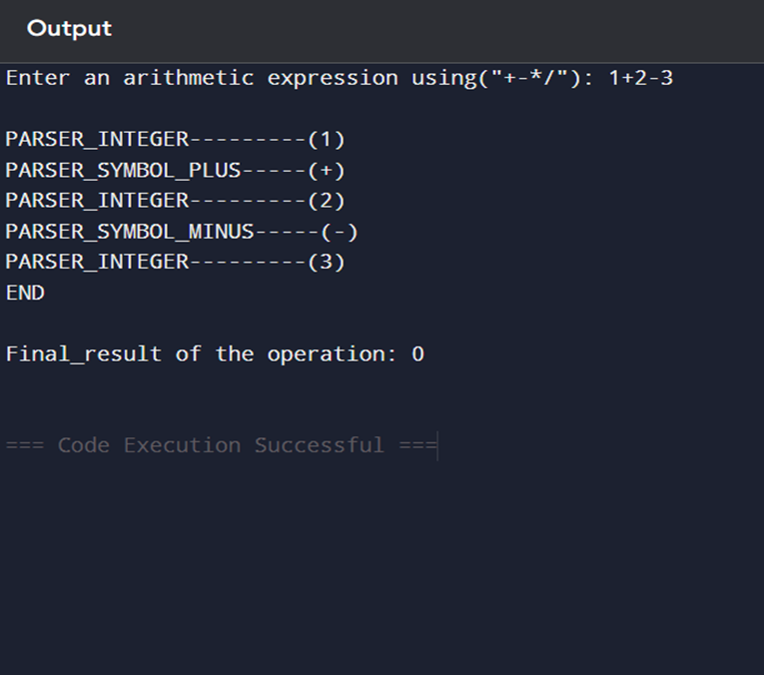

Output 2:

